THIS IS THE TITLE: READ INSTRUCTIONS CAREFULLY.

Dr. Author, John Q.

Abstract

Include a one- or two-paragraph summary of the research objective, methodology, content, and results. All text in the document is 11.5-point Times New Roman, fully justified with exception of figure titles and table titles which are to be Arial Bold Italic.. All line spacing is 1.15.

Keywords: theology, exegesis, New Testament, social justice

PAGE SETUP (MAJOR TITLE, BOLD)
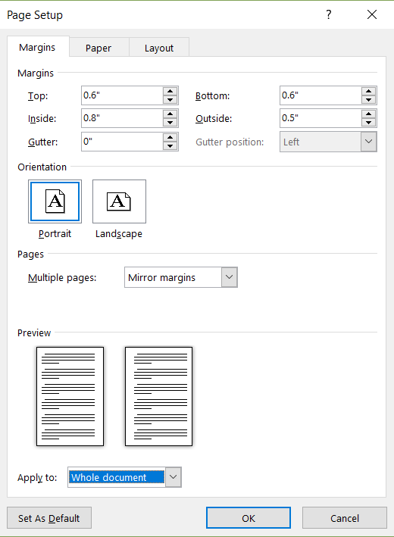
Figure 1. Margin Setup.
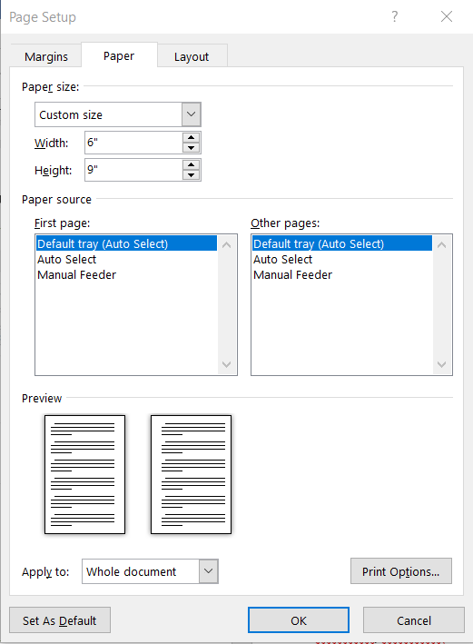
Figure 2. Page Layout Setup
Note that the margins and page layout are set up for two-sided printing in a 6” x 9” format. This formatting is the “new” standard for the AJBT as we are embarking on the printing of paperback journals. Examples of these paperbacks can be currently found on Amazon.com by searching for “The Disciple’s Bible Commentary Carter”. Papers that are submitted in a different style sheet will be converted to this format prior to publication. Historical documents will also be reformatted for paperback publishing.
All body text is to be Times New Roman, 11.5 font. Boldface is to be used for section titles.
Figure-1 illustrates the margin setup: top 0.6”, left 0.8”, bottom 0.6: and right, 0.5”. Margins are to be mirrored for double-sided printing.
Figure-2 illustrates the page setup: 6” width and 9” height.
Figure-3 illustrates the page layout setup: set different odd and even page, and place headers 0.3” from edge.
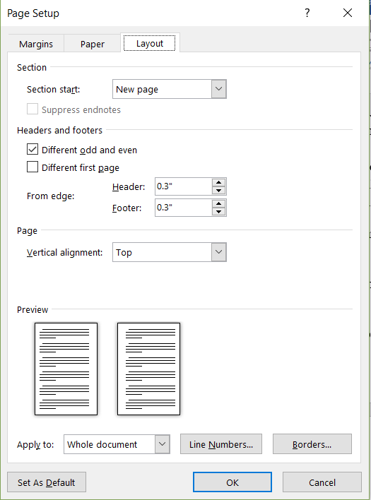
Figure-3. Page Layout Setup
BODY TEXT SETUP
Use Times New Roman, fully justified, 1.15 line spacing. Note that the running heads that include the volume number and date will be inserted by the Journal editors once the publication date has been determined. Do not place running heads in the document.

Minor Section Title.
Place complete citations as a footnote on the page that it is used. APA, MLA or Turabian styles of footnotes may be used. Turabian is preferred, and footnoting should be consistent throughout the manuscript.
Paragraphs are not indented, but are separated by a blank line or 12-points. All text is fully justified.

All pictures and tables must have a legend and must be cited in the text. Figures, tables, and legends are to be centered on the page, with the legends using Arial, boldfaced, Italics as shown here:

Table-1. This is a table title.

Figure-1. This is a figure title.

All tables and figures must be referenced somewhere within the manuscript text, referenced by Table or Figure number, preferably as close to the legend or figure as best fits the layout.

Greek & Hebrew fonts

Greek, Hebrew, or other fonts other than Times New Roman or Arial are NOT to be used. Instead, use English transliteration with italics. For example, the Greek word for God’s love is agape. The Hebrew term for God’s love is hesed. Repeat: use Times New Roman and Arial fonts only.

Page Numbers.

Page numbers may be included, and placed at the bottom of the page with the number on the outside edge. This translates to placing the numbers on the right margin of odd pages and on the left margin of even pages.
Bibliography

Bibliographical information is to be 10-point Times New Roman, left justified, single spaced, not indented, hanging 0.2” and separated by 3 points.
Lastname, First Name. Book Title. City, ST: Publisher, Date.
Lastname, First Name. Journal article title. Journal Name. Volume. Date: p XXX-XXX.

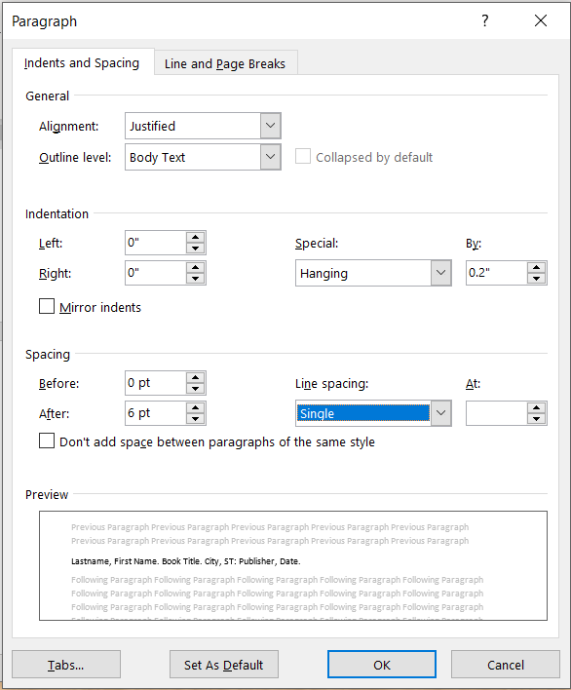
Figure-4. Bibliography Setup

Lastname, Firstname. Title of journal article, Publication. Volume x(xx), date. pXXX. Citations are left justified, 10-Point Times New Roman, and include a hanging indent of 0.2”. Use APA, Turabian, or MLA style. Be consistent throughout the document.

